Design and Construction of a Heart Monitoring Device based on a Microcontroller

# Abstract

There has been an exponential increase in cost of health care in the last decade. This period has also seen an increase in the occurrence of heart related illnesses and fatalities. Elderly citizens have to make frequent visits to their doctor to get their vital signs checked. There is a big market for non-invasive methods of measurement of vital signs such as heart rate. This project is about the design of a reliable, easy to use, low powered and accurate system that can be used on a regular basis to monitor the heart rate and send critical heart rate measurements to a specified personnel. This project specifically deals with the signal conditioning and data acquisition of the heart rate. Heart rate is measured through an infrared emitter and detector that is obtained from a person’s finger tip. The theory, design procedures, experimental results and discussions of these systems are presented.

# Contents

Abstract 2

Contents 3

Table of Figures 5

Chapter 1: Introduction 6

1.1 Background 6

1.2 Problem Statement 7

1.3 Aims and Objectives 7

1.4 Scope of Study 8

Chapter 2: Literature Review and Theoretical Framework 9

2.1 Introduction 9

2.2 Heart Monitoring Devices 10

2.2.1 Stethoscope 10

2.2.2 Pulse rate monitor 11

2.2.3 Electrocardiogram monitor (ECG monitor) 12

2.3 Electrical Activity of the Heart 13

2.4 Signal Acquisition from the Heart 14

2.4.1 Use of Electrodes 14

2.4.2 Use of IR sensors (Photoplethysmography) 15

2.5 Noise elements in the Heart Signal 16

2.5.1 Power Line Interference 16

2.5.2 Electrode Contact Noise 17

2.5.3 Instrumentation Noise 17

2.6 Heart Rate Measurement 17

2.6.1 Sampling of analog signal 18

2.6.2 Algorithm Execution 18

2.7 Displaying the Heart Rate and Signal Waveform (Heart Rhythm) 19

2.7.1 Personal Computer based displays 19

2.7.2 Portable (Liquid Crystal Display) LCD Screen 20

2.8 Emergency Signalling 21

Chapter 3: Methodology/Design Analysis and Considerations 22

3.1 Breakdown of Project 22

3.1.1 Heart Rhythm Monitor 22

3.1.2 Heart Rate monitor 23

3.2 Design Analysis 24

3.2.1 Heart Rhythm Signal Conditioning Circuit 24

3.2.2 Heart rate signal conditioning circuit 30

Chapter 4: Results and Discussion 33

4.1 Testing of filtering circuit 33

4.2 Algorithm for calculation of heart rate 39

4.3 GSM Module 42

4.4 Printed Circuit Board Design 43

4.5 Finger Clip for Infrared Sensors 46

4.6 Final Model of Heart Rate Monitor 47

4.7 Design Verification 49

4.8 Heart Rate Variability 50

4.9 Cost Analysis of Project 50

Chapter 5: Summary and Conclusion 52

References 53

Appendix 56

# Table of Figures

Figure 2.1 - Electrical Activity of the Heart (Ishbeata & Kalbouneh, 2012) 14

Figure 2.2 - Einthoven's triangle (The Student Physiologist, n.d.) 15

Figure 2.3 - Illustrating photoplethysmography (Khan, Noo, Pantho, & Abtahi, 2013) 16

Figure 2.4 - Analog to digital conversion (DeMaria, 2009) 18

Figure 2.5 - 16x2 LCD pin functions (Gajera, n.d.) 20

Figure 3.1 - Differential amplifier (ElectronicsTutorials, 2016) 25

Figure 3.2 - Schematic of the first stage amplifier 26

Figure 3.3 - First order high pass filter 27

Figure 3.4 - Third stage amplifier 28

Figure 3.5 - Passive low pass filter 28

Figure 3.6 - Heart Rhythm signal conditioning circuit 29

Figure 3.7 - Graph showing amplified output 29

Figure 3.8 - Internal circuit of LM386 30

Figure 3.9 - 2nd order low pass filter 31

Figure 3.10 - Pulse rate signal conditioning circuit 32

Figure 4.1 - 100mHz output 34

Figure 4.2 - 5Hz Output 35

Figure 4.3 - 10Hz output 36

Figure 4.4 - 20Hz Output 37

Figure 4.5 - 50Hz Output 38

Figure 4.6 - Bode plot of Filter 39

Figure 4.7 - Flowchart of Heart Rate Measurement Process 40

Figure 4.8 - Flowchart illustrating heart rate calculation 41

Figure 4.9 - Powering of GSM Module (Arduino GSM Module SIM900, n.d.) 42

Figure 4.10 - Standalone Arduino (Building an Arduino on a Breadboard, n.d.) 43

Figure 4.11 - Full schematic of Heart Rate Monitoring Circuit 44

Figure 4.12 - Printed Circuit Board Layout 45

Figure 4.13 - 3D View of Printed Circuit Board 46

Figure 4.14 - 3D Model of Finger Clip 47

Figure 4.15 - Model Showing Main Menu 48

Figure 4.16 - Finger Clip 48

Figure 4.17 - Model Measuring Heart Rate 49

# Chapter 1: Introduction

## 1.1 Background

Health is a very important area of concern in the country and the world. A huge amount of funds is reserved for maintenance of certain health standards in every country of the world. After all, an unhealthy nation is on the pathway for regression.

There are different branches of medicine or healthcare systems where improvements and development can be made. One of which is the cardiology department. Cardiology deals with disorders of the heart and the circulatory system. The heart is the organ that pumps blood to other parts of the human body; from this knowledge, once the heart fails, circulation of blood to the whole body is compromised, subsequently fatality occurs if not attended to in a timely manner.

Studies have shown that of about 50 million deaths that occur in the world, 40 million occur in the developing countries. A substantial part of this is due to cardiovascular disease (Ojikutu, 2009). This shows how critical it is to be able to curb and control the rising amount of deaths from heart diseases especially in developing countries such as Nigeria.

To prevent risks of heart failures and critical heart diseases, a form of regular monitoring is needed to constantly check on a patient. If an abnormality in the normal condition is noticed on time, the patient can be rescued and treated.

One of such diseases is Heart attack. A study has shown that 90% of heart attacks can be prevented (McGill, McMahan, & Gidding, 2008). Such preventive measures could be in form of abstinence from certain substances, dietary regulation, regular exercise and periodic monitoring of the heart function. This project is concerned with the latter of these four.

In view of the above, it is obvious that early detection of heart abnormality can be the difference between life and death in humans. A method by which heart abnormality can be detected early is with the use of a heart monitoring device which is flexible and can be used by a patient at different times.

This project introduces a non-intrusive method of designing a heart rhythm monitor as well as a heart rate monitor which can be used by a patient. Any unusual readings obtained will then be sent to a specified number for immediate response in case of emergency.

## 1.2 Problem Statement

In most developing countries, the currently available heart monitoring devices can only be found in the various health care facilities and can only be accessed when patients with heart problems are distressed. Another limitation to the use of conventional heart monitoring devices is in the elderly population who may need daily monitoring of their heart function, and who because of their old age, may be too fragile to commute to and from the hospital on daily basis.

Also, the area of cost is of utmost importance especially for use in developing countries. People should be able to have a healthy lifestyle at minimal costs. The heart monitor should not be of an exorbitant price. It should be constructed with a maximum cost in mind. It should be a perfect balance between cost, ruggedness and usability.

## 1.3 Aims and Objectives

The primary aim of this project is to design and construct a heart monitoring device capable of sending emergency messages to a healthcare professional.

The secondary objectives are:

* To design a low noise signal conditioning heart rhythm circuit
* To design a heart rate monitor that can be read easily
* To design a Global System for Mobile Communication (GSM) interfacing network for sending critical heart rate measurements to a mobile device.
* To design an overall portable and easy to use heart monitoring device

## 1.4 Scope of Study

This mobile device will be able to display the heart rhythm (which is the waveform of the heart signal) of the user while also measuring the heart rate (which is the rate of the heart beat). The combination of the rhythm and the rate of the heart beat can then be seen on a monitor by the patient. By this method, any potential risk such as heart failure or heart attack can be prevented. Also, this device can help the healthcare professional to prescribe proper medications in cases of abnormalities.

The heart rhythm monitor will consist of a

* Sensor - For collection of signals from the cardiovascular system of the body.
* Signal amplification to amplify these signals
* A Filtering Circuit – For filtering out unwanted parts of the signals and finally,
* Signal processing circuit.

The heart rate monitor will consist of similar block as the heart rhythm monitor with the difference being the type of sensors used and the display method.

The second part of the project will involve converting the analog signal to digital and processing it with a microcontroller for monitoring of the signal.

The third part will be about communicating the processed signal or information to a specified phone number (doctor) with the aid of a GSM transmitter or module.

# Chapter 2: Literature Review and Theoretical Framework

## 2.1 Introduction

The heart is a very robust organ. It can send pulses round the body. These pulses can be picked up and measured by both electronic and non-electronic means. Example of the electronic instrument is the heart rate monitor while the non-electronic instrument is the stethoscope. In 1895, Willem Einthoven made the first accurate reading of the heart rate and its development as a medical instrument (Jenkins, 2009). Years passed and the tele cardiogram was developed which sent electrocardiogram readings via telegraph lines. Portability, size and ruggedness was an issue in the use of a heart rate device. A physician known as Norman Holter developed a more rugged heart rate device that can be worn on the back. This heart monitoring device will later be known as the Holter monitor which displays and stores recorded heart rate readings. With development in wireless communication, proposals were made towards transmission of the heart rate readings wirelessly. KS Pettis et al. (Pettis, Savona, & Leibrandt, 1999) showed that 12-lead heart rate monitors transmitted wirelessly to hand-held computers is possible and can be interpreted reliably by cardiologists. Digital technology evolution has also led to improvements in heart rate devices that can be used as a portable device.

There have been several projects relating to the monitoring of the heart as it is a critical issue on the global stage. Different ideas have come up to develop heart monitoring devices that can be used to reduce recurring fatalities from heart failure.

M.N Khan et al. (Khan, Noo, Pantho, & Abtahi, 2013) designed a low cost optical sensor based heart rate monitoring system. This system consists of an infrared (IR) transmitter and receiver as the signal acquiring component and a feedback circuit to control the intensity of the IR transmitter. It makes use of active filters for the signal processing and a Bluetooth module to transmit data to the user’s cell phone for storage. Usage of active filters hinder the capability of the circuit to operate under battery powered condition.

M. Rana (Rana, 2010) developed an electronic stethoscope which makes use of a transducer that converts heart sound signal to electrical signal. The setup allows for the identification of the of the four sounds of the heart and systolic and diastolic murmurs. The limitation of this device is that it can only be used by a healthcare professional and not the patient.

Heart monitoring system which uses graphical user interface on a personal computer (Fathurrhaman, 2016) is a very good implementation. The user is able to see certain parameters concerning the heart and relate it to health standards. Easy interpretation of data from the graphical user interface is a major advantage of this implementation. A drawback of this monitoring system is its lack of portability. It must be used in the place where it is located.

In (Khairelseed, 2011) , a microcontroller based heart rate monitor was implemented. This solved the problem of lack of portability also at the expense of amount of data that can be displayed to the user. The device could measure the heart rate using algorithms developed for the microcontroller and then displaying the result on a liquid crystal display (LCD) screen.

M.G Naazneed et al. (Naazneen, et al., 2013) implemented a similar heart rate measurement device to the one stated above. By setting values to represent normal, good or bad state, the device can display the state of the heart along with the corresponding heart rate to the user. It helps a user to interpret the heart rate results easily. The device implemented can also display the waveform of the electrical activity of the heart (heart rhythm).

## 2.2 Heart Monitoring Devices

A sizeable number of devices have been invented over the years to help curb the issue of heart failure. These devices are designed with the intention to monitor the state of the heart for both domestic and hospital use.

### 2.2.1 Stethoscope

A stethoscope deals with the mechanics of the heart. It is an acoustic device that monitors the heart beat by listening to the pumping sound. It works by enhancing sounds and transmitting it to the ears. A typical stethoscope has a flat and round chest piece covered by a tight skin called the diaphragm. When a heartbeat occurs, the diaphragm vibrates and the sound travels up a hollow plastic tubing into the earpiece of the user (Monackey, 2011).

A stethoscope is a very important monitoring device and goes beyond monitoring of the heart. The disadvantage of this method is that it does not give an incisive report to the condition of the heart.

An electronic stethoscope is an upgrade to this instrument from an electrical engineering point of view. This kind of stethoscope is an improvement to the ordinary stethoscope whereby sound coming from the beating of the heart can be amplified so that the heart beat can be heard more cleanly.

### 2.2.2 Pulse rate monitor

An upgrade from the electronic stethoscope is the pulse rate monitor. This monitor can be of different forms adapted for its specific need. For example, an old person with a walking stick can have a pulse rate monitor attached or in-built to the stick.

Other forms of pulse rate monitor include:

* Chest-strap pulse rate monitors
* Wrist based pulse rate monitors

The Chest-strap heart rate monitor is worn close to the heart and hence gives a more accurate measure of the heart rate activity. It is strapped to the chest by appropriate supports and then connected to a display unit that gives a digital or numeric reading of the rate of heart beat or pulse. A signaling method such as sounding of a beep is necessary to indicate that the heart rate has crossed a certain threshold (Ladock, 2017).

The wrist based pulse rate monitor is a less intrusive instrument as it does not require uncomfortable strapping of the chest. The instrument is either worn on the wrist or placed on a fingertip. The drawback of this instrument is that it is very difficult to obtain constant readings.

### 2.2.3 Electrocardiogram monitor (ECG monitor)

The ECG monitor is a slightly more complex instrument. It displays the continuous heart activity in graphical format enabling the medical professional to check for variations in this displayed graph. The following information can be obtained from an electrocardiogram:

* Information about the rate and rhythm of heartbeats
* The size of the heart and the position of the heart chambers
* Health of the heart muscles
* Side effects of medications on the heart
* Heart abnormalities (Thomas, 2016)

Different types of ECG machines have been created. A few of them with their characteristics are listed

1. Tele cardiogram: This device was used in the past where ECG machines were very large and bulky. The information from the patient’s body is transmitted via telemetry to the ECG machine which is kept in another room because of its size. The kind of electrodes used for this machine was in the form of liquid sodium chloride. A patient will dip his arms and leg into a sodium chloride solution for conduction (Jenkins, 2009).
2. Wireless ECG: This is a modern-day concept of transmitting information from the electrodes over a wireless network. This equipment consists of electrodes that do not have wired directly connected to the ECG monitor. Hongli Yang and Jihong Chai (Hongli Yang, 2012) designed a wireless ECG monitoring system using a microcontroller to accomplish the analog-to-digital conversion, digital filtering, wave detection and heart rate calculation. It consists of a wireless transmitter at the electrodes and a receiver at the monitor. A wireless ECG machine can offer more flexibility and mobility for the patients.
3. Holter monitor: Abnormal heart behavior can be unpredictable and can occur at random interval of times. This abnormal behavior can make it difficult to monitor the heart rate using standard ECG devices. A Holter monitor is a portable ECG device that can be worn on a patient’s body for a duration of one to two days while it continuously monitors the heart. This provides a wide sample of results for more proper observation by a healthcare professional. Andrzej Zamojski (Zamojski, 2011) designed an accelerometer-based portable heart monitor that can be used together with a Holter device to supplement the overall data that can be acquired from the Holter device.
4. Cardiac loop recorder: This is similar to the Holter monitor. The duration of measurement as opposed to the holster monitor depends on the memory of the device. It is compact sized and hence portable enough to continuously record the heart rhythm over a certain duration. A loop recorder has a record button that can save the immediate few minutes prior to the start of the abnormal heart activity. When the patient experiences any heart abnormality, it can be set to automatically record the event. There is also a variant of the loop recorder which is implantable between the chest skin and rib cage.

## 2.3 Electrical Activity of the Heart

The function of the heart is to pump blood. The process or activity involved in pumping blood can be divided into six parts

* Initial depolarization of the atrium
* Final depolarization of the atrium
* Initial depolarization of the ventricles
* Final depolarization of the ventricle
* Initial re-polarization of the ventricles
* Finial re-polarization of the ventricles (Ishbeata & Kalbouneh, 2012)

This six-stage process is illustrated in Figure 2.1 to show how each stage corresponds to an electrical signal.

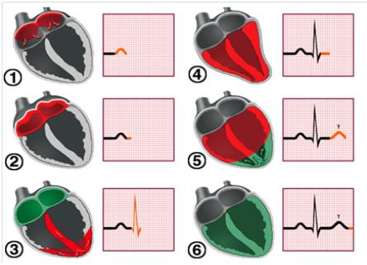

Figure 2.1 - Electrical Activity of the Heart (Ishbeata & Kalbouneh, 2012)

## 2.4 Signal Acquisition from the Heart

Two known methods by which heart signals are acquired and transduced electrically is through the use of electrodes and the use of infrared (IR) sensors.

### 2.4.1 Use of Electrodes

Electrocardiography is the process of measuring the activity of the heart using electrodes placed on the skin on the human. The electrodes are transducers that convert the activity of the heart to electrical signal. Three lead electrode placement is used for continuous monitoring of the heart beat or heart rate in situations where the patient is not in constant motion. It is best used for old people and patients under anesthesia. It requires placement of three electrodes in convenient positions where they can receive clear signal from the heart. A popular method of electrode lead placement is by the Einthoven’s triangle configuration. This method as stated earlier works well for patients at rest. In this method, the leads attached to the conducting electrodes are placed triangularly on the human body (The Student Physiologist, n.d.). The leads labelled Lead I, Lead II and Lead III are placed on the left arm, right arm and left leg respectively as shown in Figure 2.2.

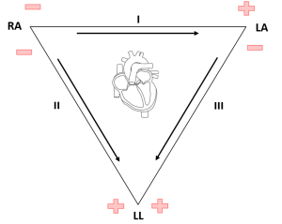

Figure .2 - Einthoven's triangle (The Student Physiologist, n.d.)

### 2.4.2 Use of IR sensors (Photoplethysmography)

The methodology behind acquiring pulse signal from the fingertip is called photoplethysmography. Photoplethysmography is a simple method which volumetric changes in the amount of blood in an organ can be detected with optical sensors. As the heart pumps blood to other parts of the body, while using an organ as reference, it is seen that the volume of blood constantly increases and reduces. A way of detecting such activity is with the use of optical sensors such as infrared emitters and detectors. Infrared emitters will transmit light through the skin and the reflection obtained will vary depending on the amount of blood at that time (Singh, Thakur, & Kumar, 2014). A very good technique in photo-plethysmography is to use the finger (usually the index finger) as the reference organ. With a light transmitter placed under the fingertip, the volumetric change of blood can be detected by varying levels of reflected light from the finger (Khan, Noo, Pantho, & Abtahi, 2013). This technique is illustrated in Figure 2.3.



Figure 2. - Illustrating photoplethysmography (Khan, Noo, Pantho, & Abtahi, 2013)

## 2.5 Noise elements in the Heart Signal

Certain noise elements and artefacts can corrupt the measurement of the heart signal and hence render the heart rate readings inaccurate. Sources of such noise are:

* Power line interference
* Electrode contact noise
* Motion artefacts
* Instrumentation noise

### 2.5.1 Power Line Interference

Power line interference in a heart monitoring device can occur as a result of capacitive and inductive coupling. Capacitive coupling means the transfer of energy between two circuits by means of a capacitor between them. Inductive coupling occurs because of mutual inductance between two conductors (Mujagic). Magnetic flux produced by the current flow through conductors is a measure of the inductance as is the separation of these conductors. Hence, for reduction in the noise caused by inductive coupling, proper placement of electrodes is essential (Mujagic). Loose wires will also introduce power line interference. Noise from capacitive coupling occurs at high frequencies and can be cut off by use of low pass filters. The occurrence of power line interference can also be prevented by using a pure dc power supply over ac supply. The disadvantage of pure dc power supply such as battery is that it is not efficient and can’t last long.

### 2.5.2 Electrode Contact Noise

Electrode contact noise “is caused by variations in the position of the heart with respect to the electrodes and changes in the propagation medium between the heart and the electrodes” (Mujagic). This can cause abrupt changes in the amplitude of the waveform of the heart signal. Poor conductivity of the skin with the electrodes is one of the main causes of this type of noise. Motion artefacts which occurs because of vibrations will also result in spikes in the amplitude of the signal.

### 2.5.3 Instrumentation Noise

Instrumentation noise occurs as a result of noise from the electronic components used in the monitoring device. Sources of this noise include electrode leads/probes, types of connecting cables, amplifiers and the analog to digital converter. This form of noise is characterized by white Gaussian noise which is present at different frequencies and can’t just be filtered off (Mujagic). The effect of instrumentation noise cannot be eliminated but can be reduced using special components such as instrumentation amplifiers which have high common mode rejection ratio and high-quality cables and electrodes.

## 

## 2.6 Heart Rate Measurement

The analog signal acquired after amplification and filtering can be passed through a device capable of operating on an algorithm that calculates the resulting heart rate. This device can be a microcontroller which is a small computer or processor with memory and other components integrated on one chip (Gridling & Weiss, 2007). The heart rate measurement process by the microcontroller can be divided into two:

* Sampling of analog signal
* Algorithm execution

### 2.6.1 Sampling of analog signal

For the heart rate to be digitized, it must go through a process called sampling. Sampling is the process by which an infinite sequence of samples ‘T’ seconds apart is obtained from a continuous time varying signal. For a continuous time signal to be accurately sampled, the rate at which samples are taken should be greater than two times the frequency of the analog signal (Orfandis, 2010). This frequency is known as Nyquist rate. Sampling in a microcontroller is carried out by an in-built analog to digital converter. The sampling procedure is illustrated Figure 2.4.

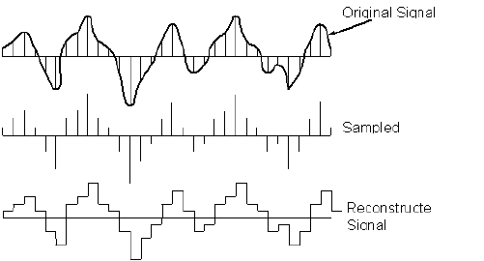

Figure 2. - Analog to digital conversion (DeMaria, 2009)

### 2.6.2 Algorithm Execution

An algorithm is a set of instructions that are followed to solve a problem. For this project scope, the problem is to determine the heart rate of a human being. There are a few rules that have been adapted to get the most accurate depiction of the heart rate. L.E. Khairelseed (Khairelseed, 2011) designed a microcontroller based heart rate monitor that calculates the heart rate by measuring the frequency of R peaks in a pulse cycle and displaying it on a screen. This method will not always give stable readings. A. Zamojski (Zamojski, 2011) made use of a comparator which sets a threshold and then compares the incoming signal peaks with the threshold to determine how many cycles have occurred. Additional circuitry is required for the use of a comparator. J.B. Maswan and A.C. Rice (Maswan & Rice, 2014) measured the pulse rate in their circuit by first converting the frequency of the heart beat to a voltage and then using that voltage to control a voltage-controlled oscillator (VCO). K.L. Chong (Chong, Holden, & Olin) calculated the heart rate in beats per minute(BPM) by measuring the total number of spikes that occur within a certain amount of time and then multiplying the count by a factor. The heart rate can also be obtained by first, checking for pulses to reduce error, then calculating the amplitude of each pulse to see whether it reaches a certain limit after which the sum of identified pulses is measured over a certain period (Pulse Sensor, 2017). These set of instructions can be coded into a microcontroller memory where the analog signal can then be processed for the final heart rate to be displayed. These set of instructions can be coded into a microcontroller memory where the analog signal can then be processed for the final heart rate to be displayed.

## 

## 2.7 Displaying the Heart Rate and Signal Waveform (Heart Rhythm)

There are a few methods of displaying the readings of the sensors placed on the body. These methods can range from being relatively cheap to being expensive. The methods can also be classified into its ability to be mobile or portable. Some display methods will show a higher degree of accuracy than others. Most displays are based on the ability of a processor or microcontroller to efficiently process the analog signal obtained from the sensors. Since these processors operate digitally, there is need for an analog to digital converter at the input of the display. A few of the display methods will be discussed.

### 2.7.1 Personal Computer based displays

Using personal computers to display the processed analog signal is a powerful method in analyzing results from the sensors. Because of the unlimited capabilities of the personal computer, one can manipulate the input heart signal to a required specification and analyze data points on the signal extensively. A computer program can be set up to work specifically on the heart signal. There are established programs available on the pc where analog signals can be processed, analyzed and displayed on the computer screen.

* MATLAB analog data acquisition: The MATLAB software detects voltage peaks using the following system. It starts with removing the low frequency components of the signal. This procedure is done using the fast fourier transform technique. A filter known as the windowed filter is then used to find the local maxima with small values being removed (Smith). This technique is repeated while the filter size is adjusted.
* Use of LabView software: LabView makes use of graphical approach in signal processing. It is an alternative to a more cumbersome coding technique. It uses a dataflow model breaking down the data processing techniques into visual maps or layouts. Raja Fathurrahman (Fathurrhaman, 2016) designed a heart rate monitor making use of the LabView software to process the signal acquired from the body.

### 2.7.2 Portable (Liquid Crystal Display) LCD Screen

With the advent of the microcontroller technology, the disadvantage in the use of a personal computer has been relieved. LCD screens can be connected to a small microcontroller which does all the signal acquiring and processing. A microcontroller is a simple computer on a chip that is programmed to a function as opposed to the general purpose personal computer. An LCD can be interfaced with a microcontroller such as an Arduino to display data already processed by the microcontroller. A common LCD screen used is the 16x2 LCD screen. The 16x2 LCD screen consists of 16 pins or terminals. Each terminal has a dedicated function for communication with the microcontroller or with a power supply.

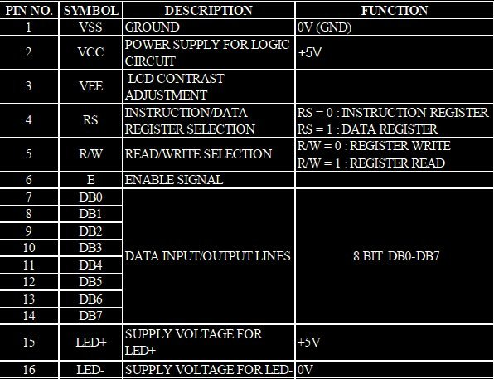

Figure 2. - 16x2 LCD pin functions (Gajera, n.d.)

## 2.8 Emergency Signalling

To prevent the heart going into critical state, a form of signaling can be implemented to make sure the attention of a medical professional is called when an abnormal heart state occurs. Emergency signaling can be in the form of sound alerts, visual alerts and electronic signals. Sound signaling involves the use of instruments that propagate loud sounds such as alarms to alert people in the immediate environment of a certain condition.

Visual alerts can be in form of bright lights of varying intensities representing the occurrence of a situation. It also can be in form of different coloured lights that are transmitted to represent a particular situation.

Electronic signaling is a very fast form of sending alerts. Electronic signals can also travel long distances via wireless medium. The use of electronic signaling is more advantageous than the two stated above. There are several electronic devices capable of sending signals through a wireless medium. One of such is the cellphone. The cellphone can transmit wirelessly through Bluetooth communication, near field communication, GSM and its evolving networks.

A GSM module is a cost-effective component that can be interfaced with a microcontroller. This module can be programmed using a microcontroller to send and receive calls and messages. The advantage of a GSM module is its capability to send messages and calls automatically as specified by the microcontroller program.

# Chapter 3: Methodology/Design Analysis and Considerations

## 3.1 Breakdown of Project

The heart monitoring is a device that combines theory of analog electronics, signal processing and embedded electronics.

The design process will be broken down into two stages:

* Design of amplification and filtering circuitry for:
  + Heart rhythm monitor
  + Heart rate monitor
* Microcontroller programming for:
  + LCD display of heart rate
  + Sending emergency message via GSM module

### 3.1.1 Heart Rhythm Monitor

The heart rhythm monitor will acquire the electrical signal from the heart through electrodes after which it will be amplified to improve the signal level and then filtered to remove noise elements.

#### 3.1.1.1 Monitor blocks

First Block: Sensor stage

A sensor or transducer is used as part of heart rhythm monitor to convert heart activity to electrical signal. An electrode which is made from a compound called Silver Chloride (AgCl) is used as the transducer in this case.

Second Block: Amplifier stage

The heart signal when obtained with the sensors are very low amplitude time varying signals. This amplitude is in the range of several millivolts (mV) and this will be unpractical to view and analyze. An amplifier comes in to increase the signal amplitude by factor of up to 5000. This keeps the amplitude level to a comfortable voltage level that can be easily viewed as well as processed digitally.

Third Block: Filtering stage:

This is a very sensitive part of the analog circuit. It involves cutting of unwanted signals in form of noise and other harmonics from the actual heart signal waveform. To filter out noise, frequency is the most important parameter that comes to play. Knowing the frequency range of the electrical activity of the human heartbeat is useful information in knowing what frequency to filter out and what frequency to leave. The bandwidth of frequency necessary to obtain the heart signal is found to be from 0.05Hz to 100Hz. Keeping this mind, a band pass filter will be constructed consisting of a high pass filter to remove any unwanted dc signal and a low pass filter to remove frequencies that are above the upper cut off of 120Hz.

### 3.1.2 Heart Rate monitor

Similar to the heart rhythm monitor, the pulse rate monitor circuit can be divided into distinct blocks. Theses blocks are listed below.

#### 3.1.2.1 Pulse rate monitor blocks

First block - Photodetector

This block is mainly the infrared transmitter and receiver which detects changes in volume of blood at the finger. Also, a light to voltage converter converts these changes to varying voltage level. This varying signal can then be transmitted to the signal conditioning circuit.

Second block – Signal conditioning circuit

This is where the signal processing begins. The varying voltage obtained from the infrared sensors is usually of several millivolts weak. Hence, it needs amplification for the signal to properly distinguished. An instrumentation amplifier is a good component that properly amplifies the pulse signal by a factor of 1000 and above. The gain of this amplifier can be set with minimal components which makes it a suitable choice. It also has a high common mode rejection ration(CMMR) for proper dc filtering. Once the signal is amplified, it undergoes filtering to remove noise signals. The pulse frequency range is within 0.1Hz to 10Hz. By knowing this, a band pass filter can be constructed with a lower cut off frequency of 0.1Hz and high cut off frequency of 10 Hz.

## 3.2 Design Analysis

Before going into the second part of the project which involves the microcontroller and GSM interfacing, design and simulation of the filtering and amplifying circuits is required. Calculations and simulations are done using the NI Multisim package from National Instruments.

Detailed description of the design and simulation done are presented.

### 3.2.1 Heart Rhythm Signal Conditioning Circuit

The signal retrieved directly from the human body has an amplitude varying from 0 to 0.5mV. The first stage involves the amplifying circuit to bring the 5mV signal to reasonable range for easy detection.

A typical amplifier circuit for this application works on the principle of the differential amplifier. A differential amplifier takes input from two signals and amplifies the difference between the two inputs by a constant factor.

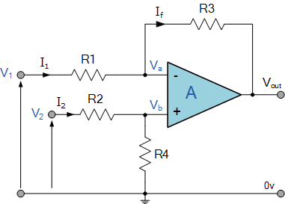

Figure 3.1- Differential amplifier (ElectronicsTutorials, 2016)

A typical solution to finding the transfer function to this amplifier is by making and . The output voltage can now be found as the difference in the two input voltages multiplied by the factor . This is expressed as (ElectronicsTutorials, 2016):

For instrumentation purposes, a more standard form of a differential amplifier with high common mode rejection ratio is used. INA126 instrumentation amplifier is used in place of the typical differential amplifier. It measures small differential voltage with high common-mode voltage developed between the non-inverting and inverting input. The high input impedance makes the INA126 suitable for a wide range of applications (INAx126 MicroPower Instrumentation Amplifier Single and Dual Versions, 2015). This amplifier is chosen also because it requires only one resistor to set the gain of the amplifier from a factor of 5 up to 10000. The schematic in Figure 3.2 shows the first stage of amplification of the heart signal using the INA126 instrumentation amplifier.



Figure 3.2 - Schematic of the first stage amplifier

The gain of the amplifier was set to 10 using the formula for calculating gain of an INA126 amplifier.

Using 10% standard resistor values, 15kΩ is chosen to set the gain, which is approximately 10.33. This initial amplification is done to raise the level of the signal so it can be properly filtered.

The second stage of the signal acquiring circuit is the high pass filter which removes any unwanted dc signal. The operating frequency range of a standard heart signal is 0.05Hz to 100Hz. The low pass filter used for this application is a first order passive filter. Though this filter may seem simplistic, it is most ideal for use in low power operations. A major disadvantage if this type of filter is that it attenuates the incoming signal.



Figure 3.3 - First order high pass filter

The lower cutoff frequency of the high pass filter is calculated as

R2 is set to a very high value of 1MΩ to maintain a high input impedance for the next op-amp stage. The value of is then calculated to become . Setting f = 0.05Hz gives the value of capacitance to be 3.2µF. As this is not a standard value, the most convenient value chosen was a 3.3µF capacitor which sets the lower cutoff frequency to 0.48Hz. This filter will have a high transition band, but nevertheless attenuates the unwanted signals to an acceptable degree.

The next stage is another amplification stage. This is where the major amplification of the signal is achieved. The signal obtained from the high pass filter is attenuated as stated earlier and hence an amplifier is needed again to boost the signal level to an acceptable value. The LMC6064 is a suitable instrumentation amplifier whose gain can be set using two resistors. This op-amp has been chosen for its ultra-low supply current and hence battery saving capability and its ability to amplify signals up to 140dB.



Figure 3.4 - Third stage amplifier

The voltage gain of this amplifier is set by the resistors R3 and R4 where voltage gain g is given by

The amplifier gain is set to 100 using resistor values of 47kΩ for R3 and 470Ω for R4.

After the signal has been amplified to an acceptable level, it is sent through the low pass filter to remove unwanted signals above 100Hz. The filter used is similar to the high pass filter stage. To design the low pass filter, the position of the capacitor and resistor is interchanged.



Figure 3.5 - Passive low pass filter

Choosing 10kΩ resistor value, the capacitor C1 value is calculated using the aforementioned formula . With the higher cutoff frequency f set to 100hz, the value of C6 is calculated to be 0.16µF. This is not a standard capacitor value, hence 0.15uF is chosen.

The low pass filter is the final stage in the signal conditioning circuit. Each stage is cascaded with the next stage to form the circuit as seen in Figure 3.6.



Figure 3.6 – Heart Rhythm signal conditioning circuit

Additional circuitry includes the current limiting resistor before the input of the first stage amplifier. The 100kΩ resistor shunt across the current limiting resistor removes any dc offsets from the electrode and acts as the reference ground. After carefully designing and choosing components, the simulated results are shown in Figure 3.7.

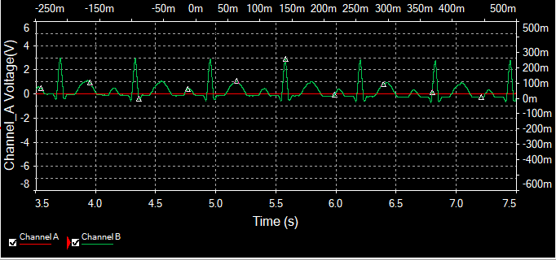

Figure 3.7 - Graph showing amplified output

The graph shown above is the result of the simulation of the circuit using the NI Multisim program. The red trace is the output of the INA126 instrumentation amplifier which barely makes the signal noticeable. The further amplification stage represented by the green stage shows the strong amplification capability of the LMC6064 amplifier.

### 3.2.2 Heart rate signal conditioning circuit

This is a fairly simple circuit consisting of the first stage amplifier and second stage low pass filter. The details of the circuit are explained below.

**Amplifier stage**

The pulse signal which is of very low amplitude will not be processed properly without proper amplification of the signal. The pulse signal obtained from the fingertip is not as sensitive to noise as the heart signal obtained from electrodes and hence doesn’t require an instrumentation amplifier. A suitable amplifier such as the LM386 operational amplifier is chosen for this particular purpose. The LM386 is a low voltage amplifier that has an integral gain of 20. This means that lesser components are needed to set the gain to a high value. The internal circuitry of the lm386 amplifier is shown in Figure 3.8.

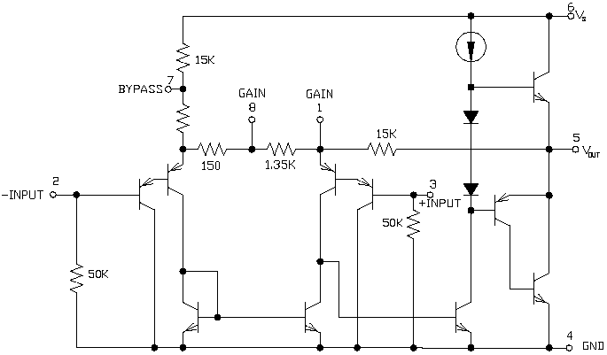

Figure 3.8 - Internal circuit of LM386

The gain of this amplifier is set by connecting a bypass capacitor across pins 1 and 8. The internal gain of the amplifier is given by the relation

The inclusion of a bypass capacitor such as a 1uF capacitor shorts the 1.35k resistor and increases the gain to

This gain value is perfectly suitable for the pulse signal.

**Low pass filter stage**

This stage helps to remove any unwanted high frequency noise from the signal. The high cut off frequency for this application is set to about 16Hz. To design this filter, a 2nd order low pass RC filter is used.



Figure 3.9 - 2nd order low pass filter

The cut-off frequency is calculated as

Setting R1 = R2 = 100Ω, C1 = C2 = C and knowing f = 16Hz, the value of C is calculated as

For convenience, 100µF capacitors is chosen for the low pass filter.

The output of the low pass filter is passed out to the microcontroller for digital processing. The whole circuitry is illustrated in Figure 3.10.



Figure 3.10 - Pulse rate signal conditioning circuit

# Chapter 4: Results and Discussion

## 4.1 Testing of filtering circuit

The signal conditioning circuit discussed in the preceding chapter was tested and simulated using sine wave input of amplitude 0.1Vp-p to see its ability to attenuate unwanted noise signals.

Test frequency 1 = 100 mHz

At 100mHz which is a rough approximation of dc signal, the simulation results show that the amplified voltage is dropped down to 130mV showing a very good attenuation of dc signal or low cut off frequency of 100mHz. This is illustrated in Figure 4.1 using the grapher function of Multisim.

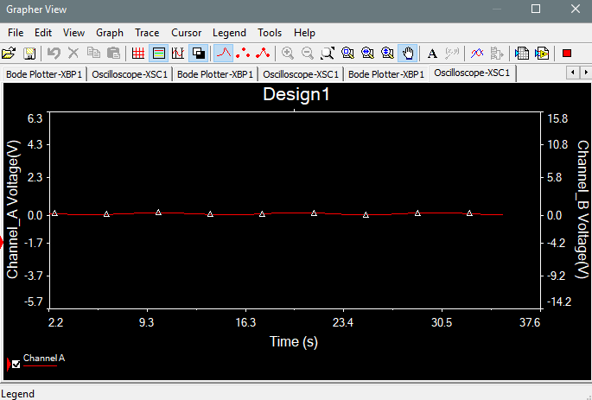

Figure 4.1 - 100mHz output

Test frequency 2 = 5 Hz

The filter is designed to pass frequencies from over 100 mHz to around 20Hz. So in practice, a 5Hz signal should have a substantial gain at the output. Using similar simulation procedure as before the 0.1Vp-p signal is amplified to 2.28Vp-p amplitude.

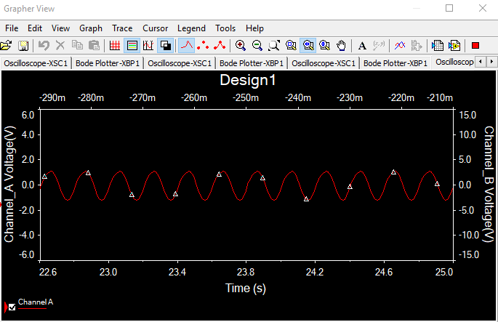

Figure 4.2 - 5Hz Output

Test frequency 3 = 10Hz

At a test frequency of 10Hz, the signal is amplified to a peak to peak voltage of 1.63. This is illustrated in Figure 4.3.

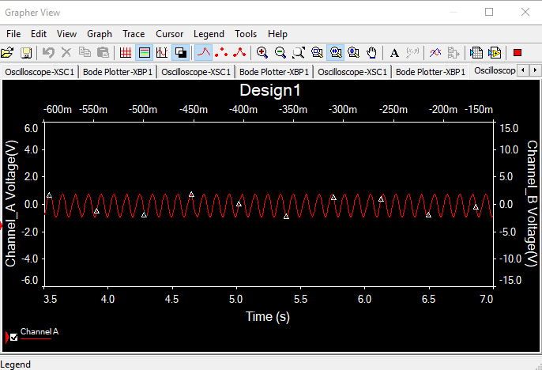

Figure 4.3 - 10Hz output

Test frequency 4 = 20Hz

At 20Hz, the signal is attenuated to a certain degree. The input signal is attenuated to a peak to peak voltage of 869mV.

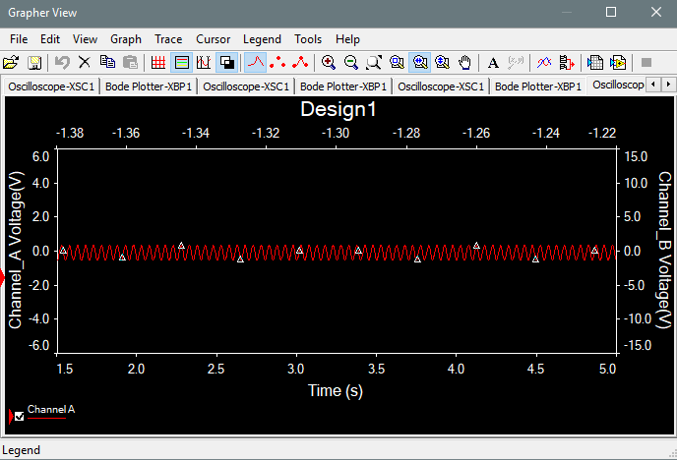

Figure 4.4 - 20Hz Output

Test frequency 5 = 50Hz

At high frequency of 50Hz, the signal is completely attenuated to a point where the peak and troughs of the sine wave is not visible. The signal is attenuated to a peak to peak voltage of 265mV.

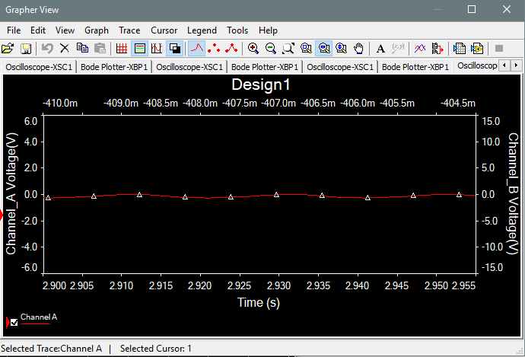

Figure 4.5 - 50Hz Output

The final bode plot showing the magnitude versus frequency characteristic of the signal conditioning circuit is shown in Figure 4.6.

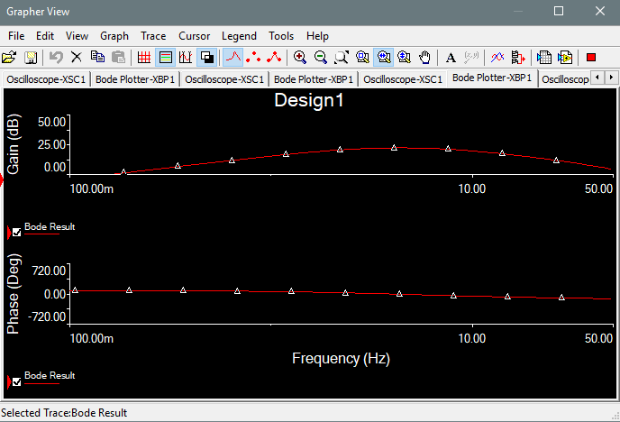

Figure 4.6 - Bode plot of Filter

## 4.2 Algorithm for calculation of heart rate

The process in which the microcontroller processes the analog pulse signal to calculate the heart rate is illustrated using the flowchart in Figure 4.7.

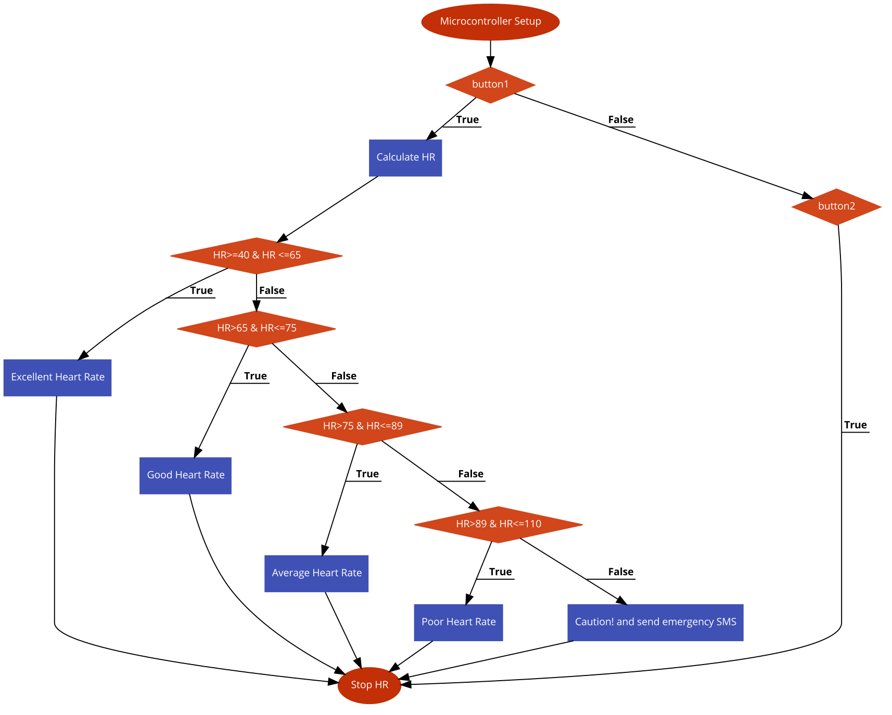

Figure 4.7 - Flowchart of Heart Rate Measurement Process

The processing of the analog signal input to display the heart rate can be illustrated using the flow chart in Figure 4.8.

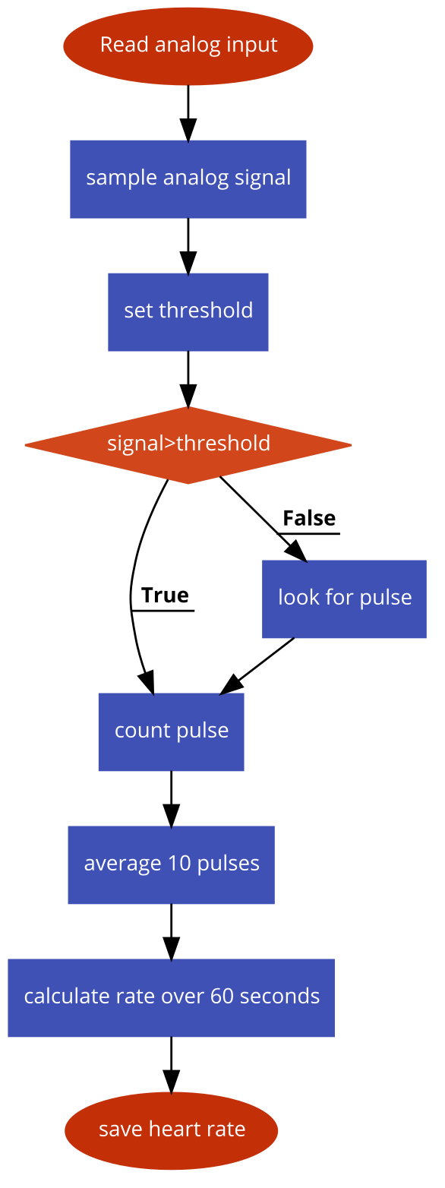

Figure 4.8 - Flowchart illustrating heart rate calculation

## 4.3 GSM Module

This is the module used to send emergency messages to the medical personnel. A sim900 GSM module which transmits on the 900MHz bandwidth. This bandwidth is available for use on telecom networks all around the country and hence suitable for this project.

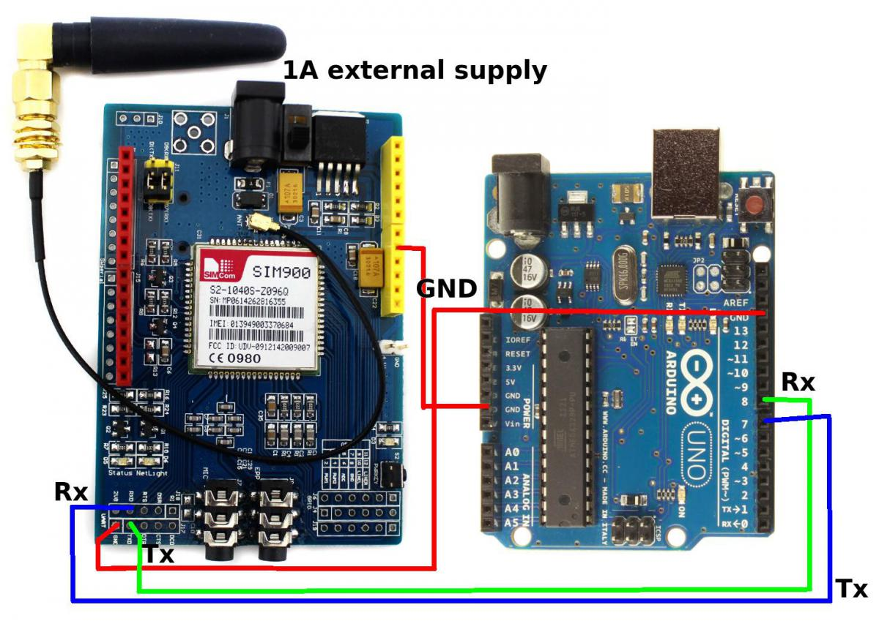

Figure 4.9 - Powering of GSM Module (Arduino GSM Module SIM900, n.d.)

The module was first powered with an external dc battery of 9V. It powered on correctly but was not capable of sending SMSs due to the low current capacity of the battery. A bigger capacity battery of 1800mAh capacity was finally chosen to drive both the module and the microcontroller. Because it is a 3.7v battery, two 1800mAh batteries were used in series to power this GSM module.

The GSM module could send a couple of SMS in quick succession with the AT commands from the Arduino microcontroller. A snippet of the code used to power on the GSM module from the microcontroller is shown in the code snippet.

void powerUp()

{

pinMode(9, OUTPUT);

digitalWrite(9,LOW);

delay(1000);

digitalWrite(9,HIGH);

delay(2000);

pinMode(9, INPUT);

}

This code ensures that the microcontroller is able to power up the module automatically without the push of a button. It passes digital pulse necessary for the starting of the module.

## 4.4 Printed Circuit Board Design

To keep the whole device to a small size, the use of printed circuit board was preferred. The circuit schematic was first drawn up with the Proteus ISIS software. Each component required for the printed circuit board alongside it’s PCB model and pin configuration was drawn up.

Also, to allow for portability, the Arduino microcontroller was transferred to a standalone form where it could be added to the printed circuit board. The standalone Arduino circuit configuration is shown in Figure 4.10.

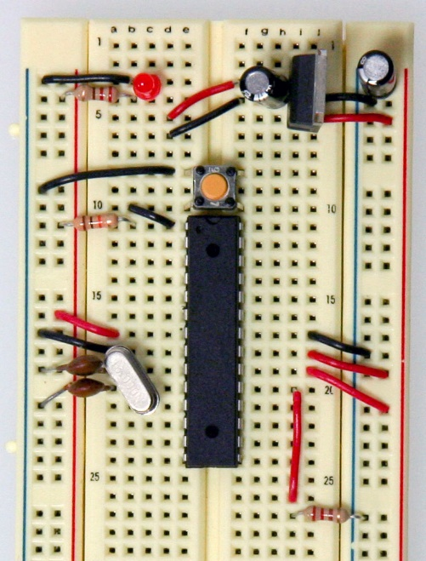

Figure 4.10 - Standalone Arduino (Building an Arduino on a Breadboard, n.d.)

The final schematic is of the heart rate circuit is shown in Figure 4.11.



Figure 4.11 - Full schematic of Heart Rate Monitoring Circuit

This schematic is transferred to the Proteus Aries software where the schematic is configured to a suitable sized printed circuit board layout.



Figure 4.12 - Printed Circuit Board Layout

This printed circuit board layout was designed using a two-layered technique to conserve size and save cost of printed circuit board fabrication.

The three-dimensional view of this circuit is shown in Figure 4.13.

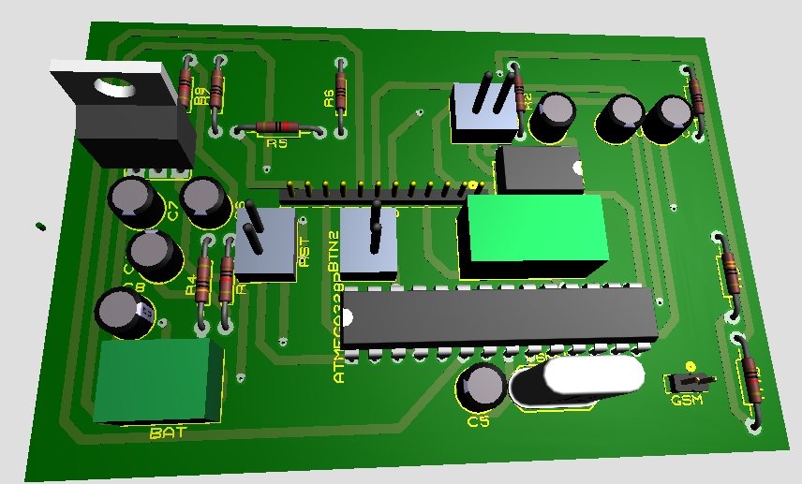

Figure 4.13 - 3D View of Printed Circuit Board

## 4.5 Finger Clip for Infrared Sensors

The infrared detector used for this project is sensitive to light from different directions, hence it is necessary for the sensors to be kept enclosed in a suitable case. A 3d printout of a finger clip model was most convenient for this application. The clip was fabricated using relatively new 3d printing technology making use of plastic as the material of print. The finger clip model was modified using Autodesk Fusion 360 software. The 3d model is shown in Figure 4.14.

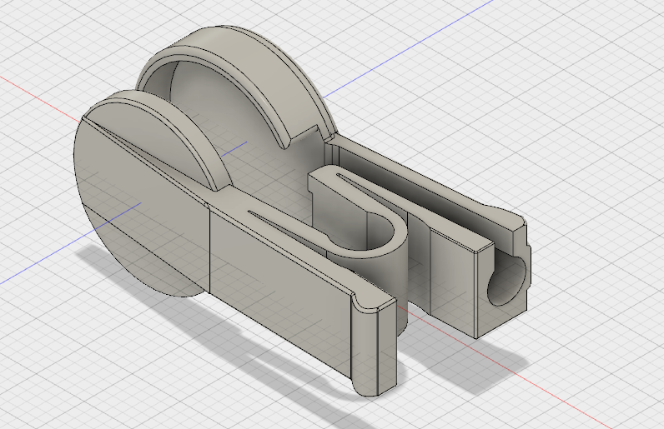

Figure 4.14 - 3D Model of Finger Clip

## 4.6 Final Model of Heart Rate Monitor

The printed circuit board alongside the GSM module was encased in an 11.5cm x 9cm x 5.5cm PVC (polyvinyl chloride) case. This ensured a lightweight and portable enclosure for the heart rate monitor. The use of plastic material also enabled the transmission of microwaves with ease from the GSM module out of the material. Snapshots of the model are shown in Figure 4.15 – Figure 4.17.

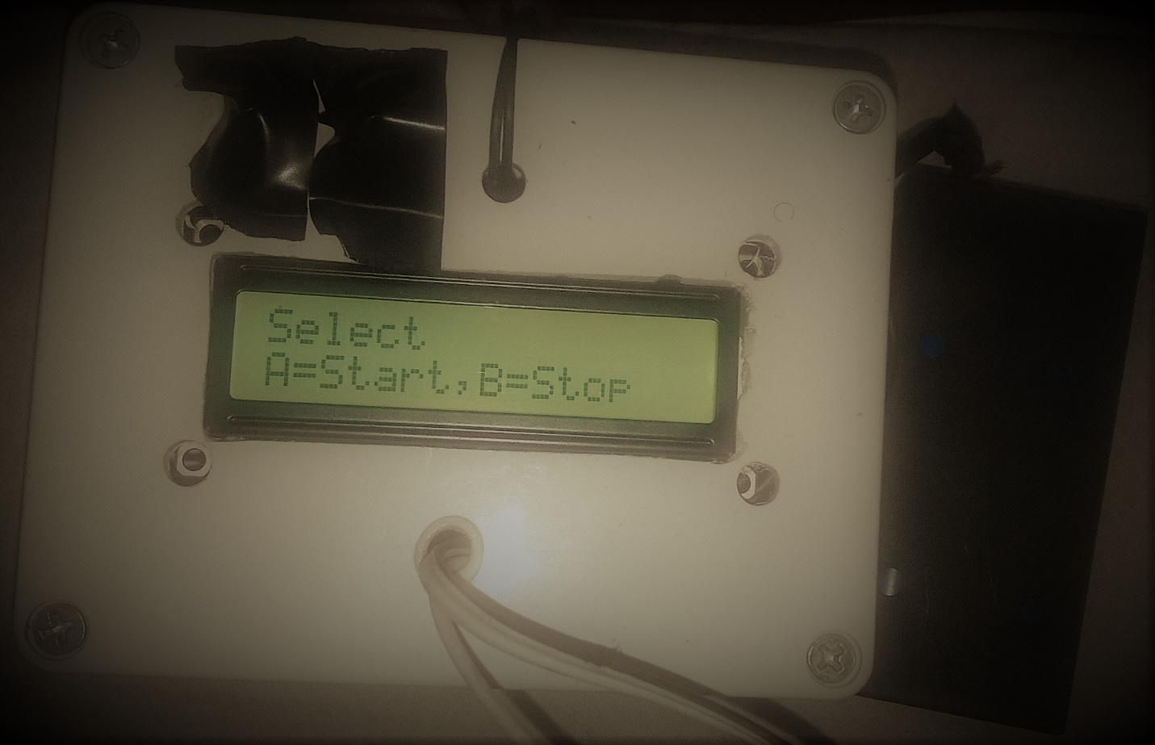

Figure 4.15 - Model Showing Main Menu

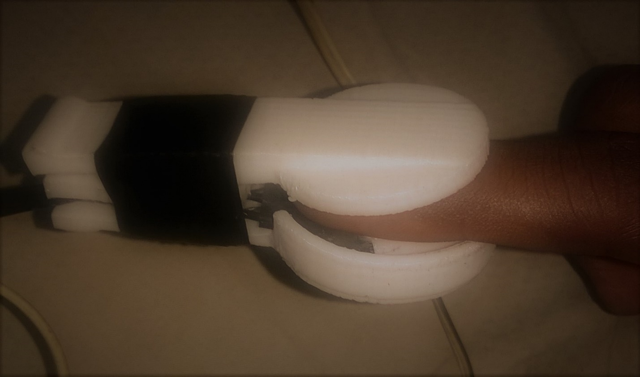

Figure 4.16 - Finger Clip

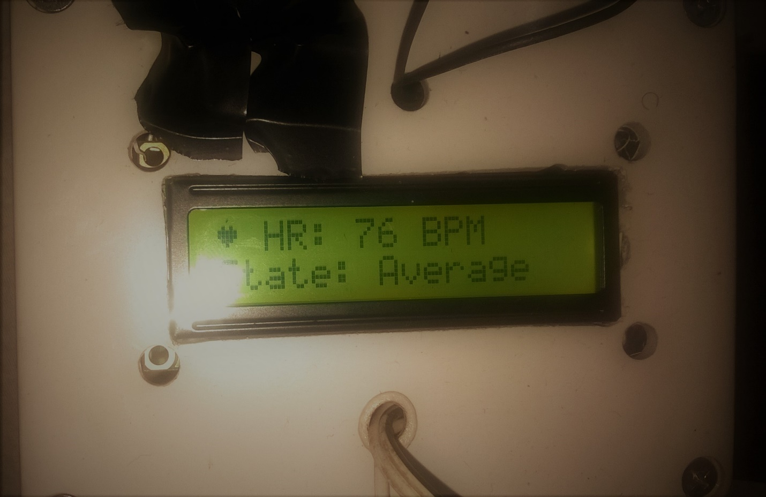

Figure 4.17 - Model Measuring Heart Rate

## 4.7 Design Verification

The heart rate monitor was put to test alongside a Samsung Mobile Device capable of measuring a person’s heart rate. The results of this model versus the Samsung model of five different people are tabulated below in Table 1.

|  |  |  |
| --- | --- | --- |
|  | Project Model (Heart Rate in BPM) | Samsung Model (Heart Rate in BPM) |
| Person A | 76 | 73 |
| Person B | 61 | 56 |
| Person C | 85 | 79 |
| Person D | 72 | 70 |
| Person E | 89 | 80 |

Table - Table showing degree of accuracy of model

A slight deviation is observed between the project model and the Samsung model. The maximum deviation of the output heart rate is seen to be 9BPM occurring for Person E who was considerably older than the others. This shows that this project model is relatively accurate and precise for less older users. Though it can be used for all ages as its range is wide.

To test its ability to send emergency messages, the finger clip was maneuvered in a rapid way different from normal use to simulate a very high heart rate. For simulated heart rates of 112BPM and 124BPM, warning messages were successfully sent. For heart rates below 110BPM, only status messages were shown on the LCD.

## 4.8 Heart Rate Variability

Heart rate variability is a measure of the changes in the beat-to-beat heart rate (Clifford, 2002). This is a key indicator of an individual’s cardiovascular condition. The heart rate monitor model records the heart rate of a person in real time and shows how the heart rate varies within an interval. This can be a useful tool in clinical diagnosis. The heart rate variability of Person A discussed in previous section was in the range of 73-80 BPM. A lower heart rate variability is a healthier status.

## 4.9 Cost Analysis of Project

One of the aims of this project is related to cost effectiveness. Analysis of the total cost of components, casing and other miscellaneous services used in the completion of this project is shown in Table 2.

|  |  |
| --- | --- |
| Part | Price (N) |
| Arduino Microcontroller | 4000 |
| LM386 IC | 300 |
| Capacitors (8) | 80 |
| Resistors (10) | 100 |
| LM7805 Regulator | 50 |
| Buttons (3) | 30 |
| 16 MHz Crystal | 50 |
| LCD | 750 |
| PCB Fabrication | 3000 |
| Casing | 1500 |
| Batteries | 600 |
| Total | **10460** |

Table - Table showing total cost of model

From the table above, the total cost of this project is seen to be just below N11000. This shows a relatively cheap means of monitoring one’s heart rate.

# Chapter 5: Summary and Conclusion

The objective of this project was to build a low power, reliable, low cost, non-intrusive monitoring system that would accurately measure the heart rate of an individual and would also be capable of sending emergency messages. A reliable heart rate monitoring system has been successfully built with a relatively small cost. This device is also easy to use and provides accurate measurements.

The initial scope of the project was to add an electrocardiogram to display the heart rhythm on an oscilloscope. Due to portability and casing issues, the electrocardiogram was left out of the project.

This project can be improved and expanded in numerous ways. First of all, the heart pulses can be displayed electronically using a small oscilloscope. This will give the user a graphical outlook on his heart rate condition and hence better monitoring experience. Digital filtering can be used in place of the analog filtering. This will reduce the overall size of the device and make it easier to use.

The sensor used could be modified to be wireless to enable full portability of the user with the device. The heart signals could be passed through wireless technology such as Wi-Fi or Bluetooth. But this might come at a cost.

Lastly, the scope of this project can be improved to monitor other vital signs such as temperature and blood pressure. Oxygen level in the blood could also be checked with a better photo plethysmograph method.

In conclusion, with refinements to the design, the heart rate monitoring device would make a great competitor against other products that currently exist in the market.

# References

Antonicelli, R. (2012). Validation of the 3-lead tele-ECG versus the 12-lead tele-ECG and the conventional 12-lead ECG method in older people. *PubMed*, 104-108.

*Arduino GSM Module SIM900*. (n.d.). Retrieved from Hobbyist.co.nz: http://www.hobbyist.co.nz/?q=arduino-gsm-module

*Building an Arduino on a Breadboard*. (n.d.). Retrieved from Arduino: https://www.arduino.cc/en/Main/Standalone

Chong, K., Holden, D., & Olin, T. (n.d.). *Australian National University: College of Engineering & Computer Science.* Retrieved May 2, 2017, from http://users.cecs.anu.edu.au/~Salman.Durrani/_teaching/TA1.pdf

Clifford, G. D. (2002). *Signal Processing Methods for Heart Rate Variability.* Retrieved from Cite Seerx: http://citeseerx.ist.psu.edu/viewdoc/download?doi=10.1.1.103.420&rep=rep1&type=pdf

DeMaria, M. (2009). *Azima DLI*. Retrieved May 5, 2017, from http://azimadli.com/vibman/analogtodigitalconversion.htm

*ElectronicsTutorials*. (2016). (AspenCore) Retrieved April 1, 2017, from http://www.electronics-tutorials.ws/opamp/opamp_5.html

Fathurrhaman, R. (2016, December 14). *Heart Rate Monitoring System.* Retrieved May 3, 2017, from https://create.arduino.cc/projecthub/hrms/heart-rate-monitoring-system-8da2fa

Gajera, U. (n.d.). *Oc Freaks*. Retrieved May 4, 2017, from http://www.ocfreaks.com/interfacing-16x2-lcd-with-lpc2148-tutorial/

Gridling, G., & Weiss, B. (2007). Microcontroller Basics. In *Introduction to Microcontrollers* (p. 2). Vienna University of Technology.

Hongli Yang, J. C. (2012). The Study and Design of a Wireless ECG Montitoring System. *Biomedical Instrumentation & Technology*, 395-399.

Ishbeata, A., & Kalbouneh, M. (2012, 11 01). *Engineers Labs*. (Engineers Labs) Retrieved 03 04, 2017, from http://engineerslabs.com/2012/01/ecg-circuit-analysis-and-design-simulation-by-multisim/

Jenkins, D. (2009, May 11). *ECG Library*. Retrieved May 8, 2017, from http://www.ecglibrary.com/ecghist.html

Khairelseed, L. E. (2011). *Microcontroller Based Heart Rate Monitor Using Fingertip Sensor.* Retrieved May 2, 2017, from http://khartoumspace.uofk.edu/bitstream/handle/123456789/18587/Microcontroller%20Based%20Heart%20Rate.pdf?sequence=1

Khan, M., Noo, D., Pantho, M., & Abtahi, T. (2013). A Low Cost Optical Sensor Based Heart Rate. *2013 International Conference on Informatics, Electronics and Vision (ICIEV).* Bangladesh: Bangladesh University of Engineering and Technology.

Ladock, J. (2017). *HealthGuidance*. (Health Guidance) Retrieved from http://www.healthguidance.org/entry/12117/1/Types-of-Heart-Rate-Monitors.html

Maswan, J., & Rice, A. (2014, May 15). *Massachusetts Institute of Technology.* Retrieved May 2, 2017, from http://web.mit.edu/6.101/www/s2014/projects/jbmaswan_Project_Final_Report.pdf

McGill, H. C., McMahan, C. A., & Gidding, S. S. (2008). Preventing Heart Disease in the 21st Century: Implications of the Pathobiological Determinants of Atherosclerosis in Youth (PDAY) Study. *Contemporary Reviews in Cardiovascular Medicine*, 1216.

Monackey, H. (2011, September 7). *WakeMed Voices Blog*. (WaleMed) Retrieved 2017, from http://wakemedvoices.org/2011/09/did-you-ever-wonder-how-a-stethoscope-works/

Mujagic, M. (n.d.). *Characterization of ECG Noise Sources.*

Naazneen, M. G., Sumaya, F., Mohammadi, S., Indikar, I., Saleem, A., & Jebran, M. (2013). Design and Implementation of ECG Monitoring and Heart Rate Measurement System. *International Journal of Engineering Science and Innovative Technology, 2*(3), 456-465.

Ojikutu, R. K. (2009). The Prevalence Of Cardiovascular Disease In Lagos State, Nigeria. *Ghana Journal of Development Studies*, 42.

Orfandis, S. J. (2010). Sampling and Reconstruction. In *Introduction to Signal Processing* (p. 6). Pearson Education, Inc.

Pettis, K., Savona, M., & Leibrandt, P. (1999). Evaluation of the efficacy of hand-held computer screens for cardiologists' interpretations of 12-lead electrocardiograms. *US National Library of Medicine*, 765-770.

*Pulse Sensor*. (2017). (World Famous Electronics) Retrieved May 13, 2017, from https://pulsesensor.com/pages/pulse-sensor-amped-arduino-v1dot1

Rana, M. (2010, December 13). *Report on Electronic Stethoscope.* Retrieved from https://www.scribd.com/doc/45188266/Project-Report-on-Electronic-Stethoscope

Singh, V., Thakur, S., & Kumar, V. (2014). Application of Heart Photoplethysmography. *International Journal of Electrical, Electronics and Data Communication, II*(3), 65-69.

Smith, S. (n.d.). Windowed-Sinc Filters. In *Digital Signal Processing: A Practical Guide for Engineers and Scientists* (p. 285).

*Texas Instruments.* (2015, December). Retrieved April 27, 2017, from http://www.ti.com/product/INA126/datasheet

*The Student Physiologist*. (n.d.). (Online Cardiology Resource) Retrieved May 3, 2017, from https://thephysiologist.org/study-materials/the-ecg-leads-polarity-and-einthovens-triangle/

Thomas, D. A. (2016, April 3). *Medicwiz*. (Concise Health Insight) Retrieved 2017, from https://www.medicwiz.com/medtech/diagnostics/10-types-of-ecg-devices-for-heart-rhythm-monitoring

Zamojski, A. (2011). *Patient Activity Monitor for Holter Examination.* Texas Instruments Incorporated.

# Appendix

Arduino code for calculation and output of heart rate.

#include <**LiquidCrystal**.h>

#include <**SoftwareSerial**.h>

**LiquidCrystal** lcd(12, 11, 5, 4, 3, 2);

**SoftwareSerial** mySerial(7, 8);    //gsm transmission pin

#include <**Pushbutton**.h>

#define BUTTON_PIN A2

#define BUTTON_PIN2 A3

int pulsePin = A0;                 // Pulse Sensor purple wire connected to analog pin 0

int blinkPin = 13;                // pin to blink led at each beat

volatile int BPM;                   // int that holds raw Analog in 0. updated every 2mS

volatile int Signal;                // holds the incoming raw data

volatile int IBI = 600;             // int that holds the time interval between beats! Must be seeded!

volatile boolean Pulse = false;     // "True" when User's live heartbeat is detected. "False" when not a "live beat".

volatile boolean QS = false;        // becomes true when Arduino finds a beat.

volatile int rate[10];                      // array to hold last ten IBI values

volatile unsigned long sampleCounter = 0;   // used to determine pulse timing

volatile unsigned long lastBeatTime = 0;    // used to find IBI

volatile int P =512;                        // used to find peak in pulse wave, seeded

volatile int T = 512;                       // used to find trough in pulse wave, seeded

volatile int thresh = 530;                  // used to find instant moment of heart beat, seeded

volatile int amp = 0;                       // used to hold amplitude of pulse waveform, seeded

volatile boolean firstBeat = true;          // used to seed rate array so we startup with reasonable BPM

volatile boolean secondBeat = false;        // used to seed rate array so we startup with reasonable BPM

byte heart[8] =                        //heart character creation

{

 0b00000,

 0b01010,

 0b11111,

 0b11111,

 0b01110,

 0b00100,

 0b00000

};

**Pushbutton** button(BUTTON_PIN);

**Pushbutton** button2(BUTTON_PIN2);

void setup()

{

 pinMode(blinkPin,OUTPUT);        //led heartbeat indicator

 lcd.createChar(1, heart);

 lcd.begin(16,2);

 mySerial.begin(115200);

 interruptSetup();                 // sets up to read Pulse Sensor signal every 2mS

 powerUp();

}

void loop()

{

 do

 {

   while (button.isPressed());   // wait for button to be released

   delay(10);                    // debounce the button release

   while (button2.isPressed());   // wait for button to be released

   delay(10);                    // debounce the button release

 }

 while (button.isPressed());     // if button isn't still released, loop

 while (button2.isPressed());     // if button isn't still released, loop

 mode_select();

}

void mode_select()

{

 while(true)

 {

     mode_text();

    if(button.getSingleDebouncedRelease())

     {

       mode_select();

     }

     if(button2.getSingleDebouncedRelease())

     {

       pulse_select();

     }

  }

}

void mode_text()

{

 lcd.setCursor(0,0);

 lcd.print("Select          ");

 lcd.setCursor(0,1);

 lcd.print("A=Start,B=Stop  ");

}

ISR(TIMER1_OVF_vect)

{

 cli();

 Signal = analogRead(pulsePin);          //Read from ther ir sensor

 sampleCounter +=2;                      //keep track of time every 2mS

 int N = sampleCounter - lastBeatTime;    //pass time before pule check

 if(Signal<thresh && N>(0.6*IBI))        //check for lowest point of analogRead

 {

   if(Signal<T)

   {

     T = Signal;

   }

 }

 if(Signal>thresh && Signal>P)           //check for highest point of analogRead

 {

   P = Signal;

 }

 if(N>250)

 {

   if((Signal>thresh)&&(Pulse==false)&&(N>(0.6*IBI)))

   {

     Pulse = true;

     digitalWrite(blinkPin, HIGH);

     IBI = sampleCounter - lastBeatTime;

     lastBeatTime = sampleCounter;

     if(secondBeat)

     {

       secondBeat = false;

       for(int i=0; i<=9; i++)

       {

         rate[i] = IBI;

       }

     }

     if(firstBeat)

     {

       firstBeat = false;

       secondBeat = true;

       sei();

       return;

     }

     word runningTotal = 0;

     for(int i=0; i<=8; i++)

     {

       rate[i] = rate[i+1];

       runningTotal += rate[i];

     }

     rate[9] = IBI;

     runningTotal += rate[9];

     runningTotal /= 10;

     BPM = 60000/runningTotal;

     QS = true;

   }

 }

 if(Signal<thresh && Pulse==true)

 {

   digitalWrite(blinkPin,LOW);

   Pulse = false;

   amp = P - T;

   thresh = amp/2 + T;

   P = thresh;

   T = thresh;

 }

 if(N>2500)

 {

   lcd.clear();

   thresh = 530;

   P = 512;

   T = 512;

   lastBeatTime = sampleCounter;

   firstBeat = true;

   secondBeat = false;

 }

 sei();

}

void pulse_select()

{

 while(true)

 {

   pulseOutput();

  }

}

void pulseOutput()

{

 lcd.clear();

 lcd.print("wait...");

 delay(2000);

 while(true)

 {

   if(button.getSingleDebouncedRelease())

     {

       mode_select();

     }

   if(QS == true)

   {

     lcd.setCursor(0,0);

     lcd.write(1);

     lcd.print(" HR: ");

     lcd.print(BPM);

     lcd.print(" BPM");

      if(BPM>=40&&BPM<=65)

       {

         lcd.setCursor(0,1);

         lcd.print("State: Excellent");

       }

       else if(BPM >65&&BPM<=75)

       {

         lcd.setCursor(0,1);

         lcd.print("State: Good     ");

       }

       else if(BPM>75&&BPM<=89)

       {

         lcd.setCursor(0,1);

         lcd.print("State: Average  ");

       }

       else if(BPM>89&&BPM<=110)

       {

         lcd.setCursor(0,1);

         lcd.print("State: Poor     ");

       }

       else if(BPM>110&&BPM<=160)

       {

         lcd.setCursor(0,1);

         lcd.print("Caution!        ");

         gsm_alert();

       }

      QS = false;

   }

 }

}

void interruptSetup()

{

 TCCR1A = 0x00;

 TCCR1B = 0x11;

 TCCR1C = 0x00;

 TIMSK1 = 0x01;

 ICR1 = 16000;

 sei();

}

int sms_count=0;

void gsm_alert()

{

 while(sms_count<3)

 {

   SendTextMessage();

 }

}

void SendTextMessage()

{

 mySerial.println("AT+CMGF=1");                     //To send SMS in Text Mode

 delay(1000);

  mySerial.println("AT+CMGS=\"+2348172758055\"\r"); //medical personnel phone number

 delay(1000);

 mySerial.println("Heart Rate of ");                     //the content of the message

 mySerial.println(BPM);

 mySerial.println("Contact Patient");

 delay(200);

 mySerial.println((char)26);//the stopping character

 delay(1000);

  mySerial.println("AT+CMGS=\"+2348172758055\"\r");

 delay(1000);

 mySerial.println("Heart Rate of ");

 mySerial.println(BPM);

 mySerial.println("Contact Patient");

 delay(200);

 mySerial.println((char)26);//the message stopping character

 delay(1000);

 sms_count++;

}

void powerUp()

{

pinMode(9, OUTPUT);

digitalWrite(9,LOW);

delay(1000);

digitalWrite(9,HIGH);

delay(2000);

pinMode(9, INPUT);

}